How do I create a distribution list in Outlook

- Click on file, then select the contacts icon

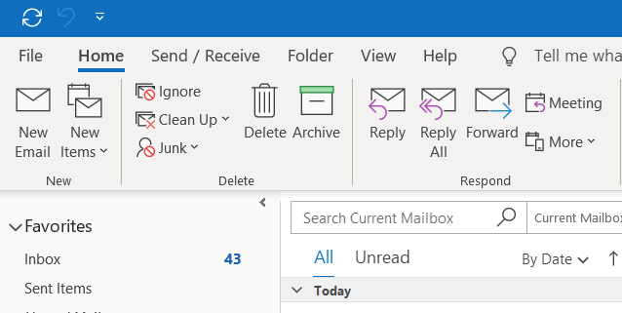

- Click on contacts

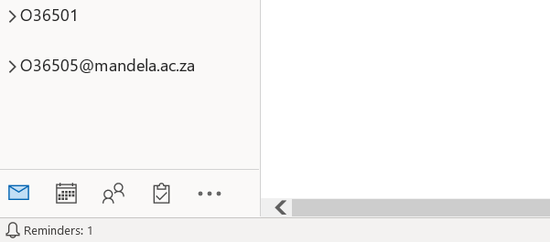

- Click On New Contact Group
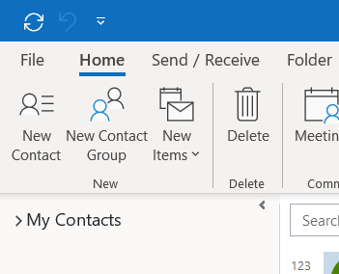

- Give the Distribution list a name
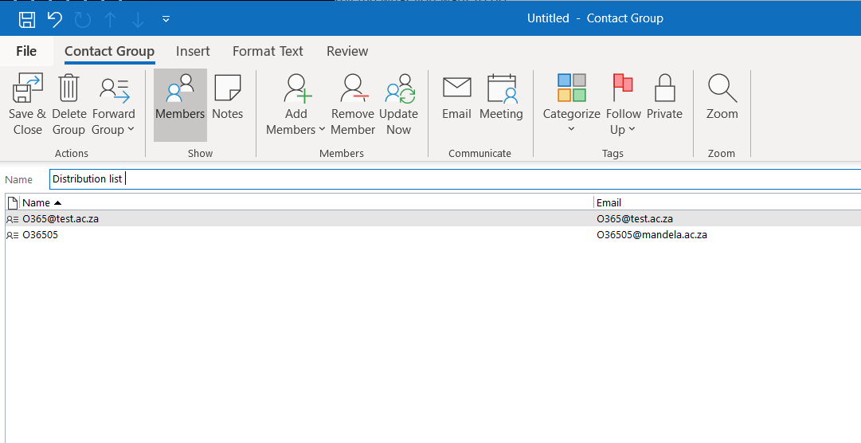

- Click on Add Members and choose the source. (For this example we using Address Book)

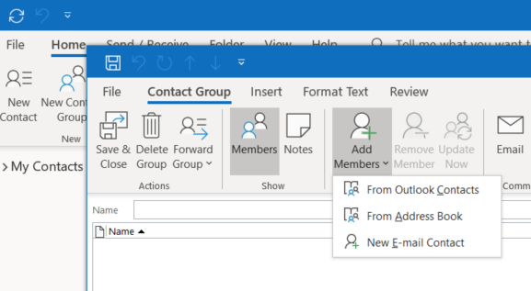

- Click on address book and search for the name and double click on the member to add, and if the member is an external user, type or paste the email address next to members and click ok

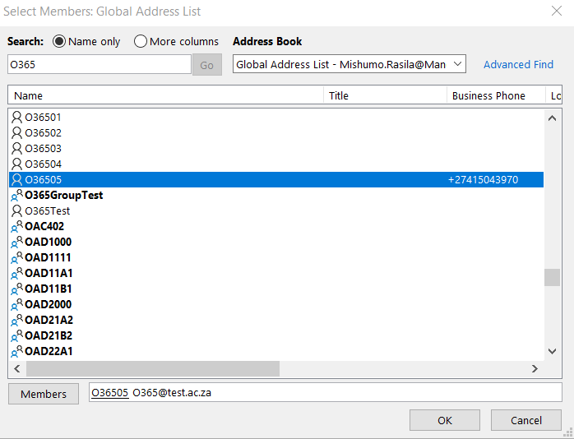
- Click on save and close

