How do I change my picture on Outlook

- Click on File
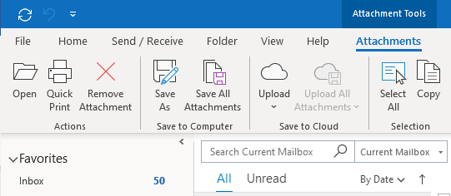

- Click on change
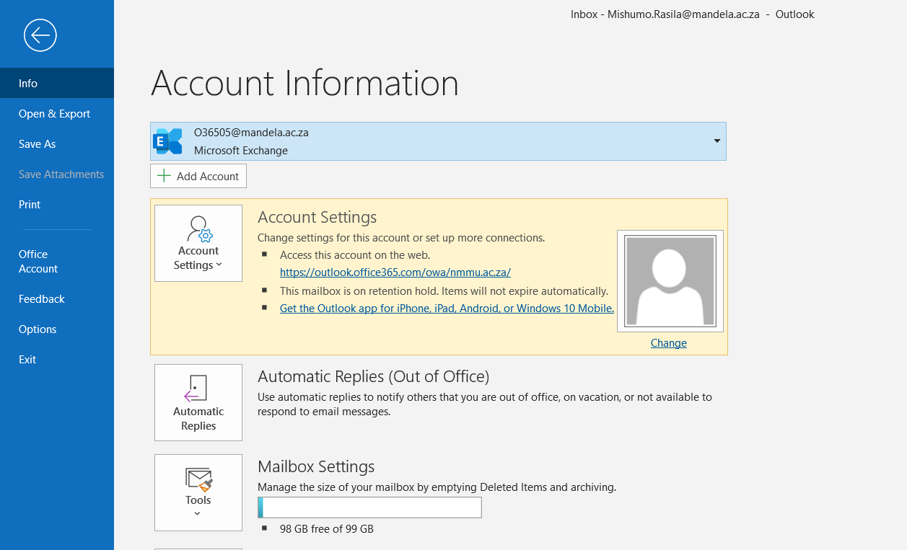

- You will get a login window to your office365 account, enter your username@mandela.ac.za
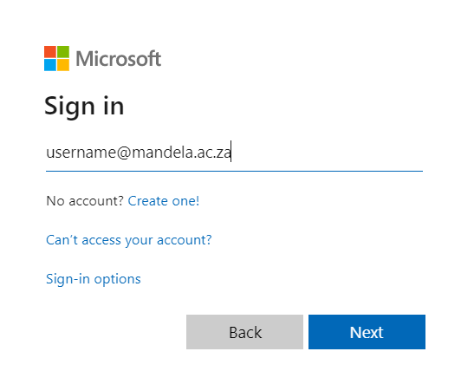
- A pop up dialog box will come up (Please enter username@mandela.ac.za and password then click Ok
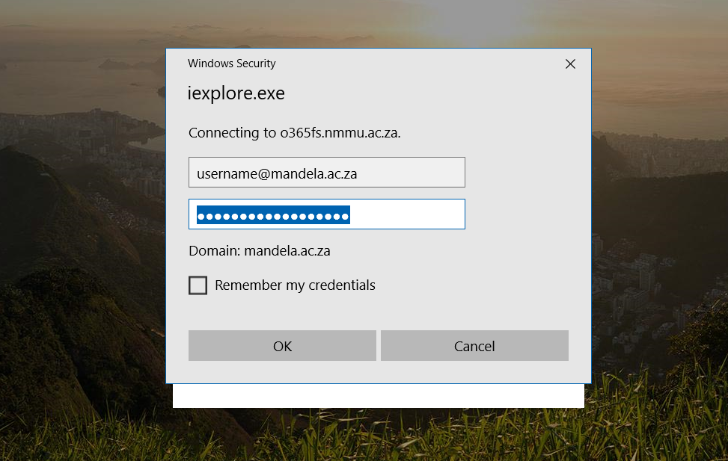

- Select Upload a new photo
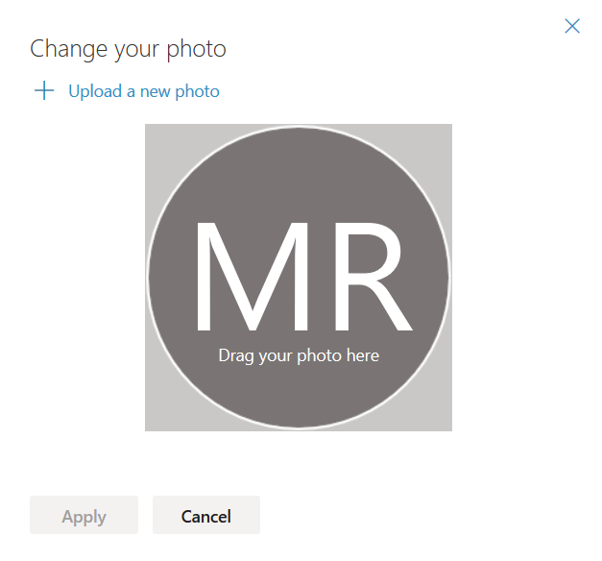

- Find the picture’s location on your pc, click open
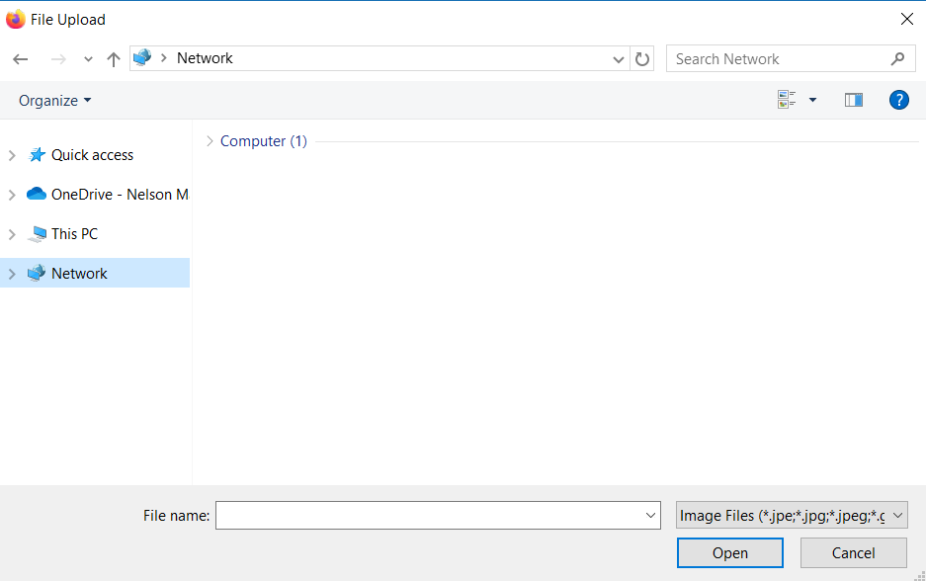

- Click Apply

