How to block an Email Address or a Domain that is sending Spam via Outlook.
- On the Home Tab, click on down arrow next to the Junk option, then Junk E-Mail Options
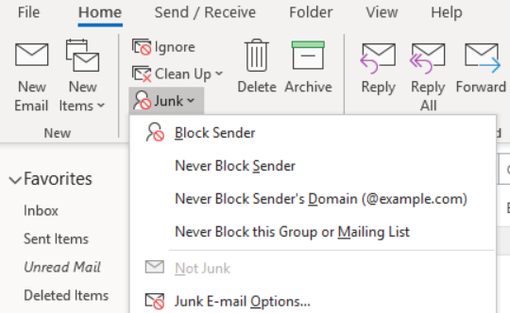

- Click on Blocked senders
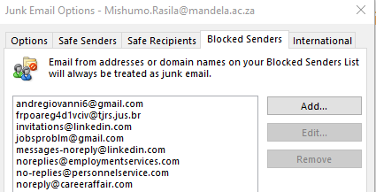

- Click on Add button, type in the email address or the internet domain and click OK
