How to Use Polly for Surveys
- Polly needs to be added as an app
- In your team Click to add another tab (+)
- Click on the Polly app
- Click “Add”
- You are ready to create Surveys
- In the Posts channel of the General Section, at the bottom you will see a Polly icon (this will be the same for any chat channel you create)
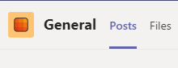
- Click on the Polly icon (looks like a parrot). This is done each time you need to add a poll.
- A screen will pop up
- You can choose if you want a Poll or a Survey
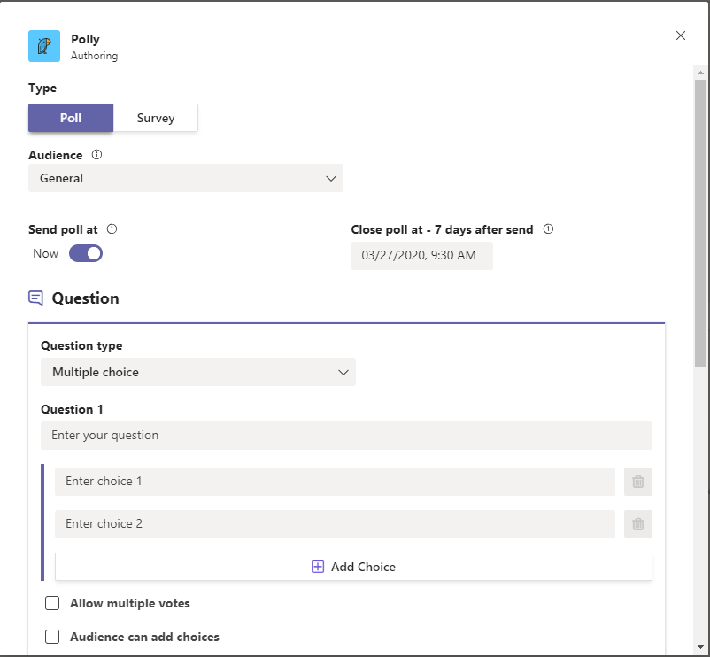
Surveys

- Type a Survey title and a Message to your Team
- Choose when you would like to send it
  - You can choose now (default as below screen)
  - Or Schedule a Start date and time. Click on the slider by Now

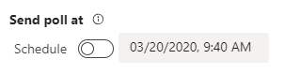
  - Here you can schedule the date and time you want it to start
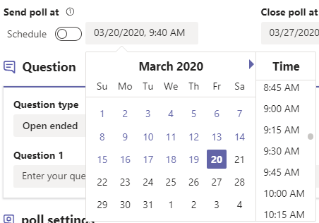

- Choose and End date and time

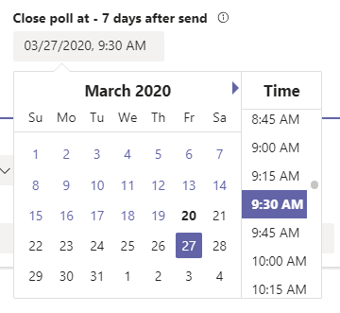
- Next Choose the Question Type for EACH QUESTION added you will need to choose the question Type
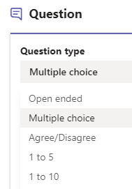
  - Open Ended Question Type
    - Type in your question and if it is “required” to be answered or not
    - Choose the Result Settings for the question and the Audience Settings for the question
    - Click “Preview”
    - Here you can “Edit” or Send it to the Team
    - Survey is posted in the General channel
    - Members can now “Start Survey”. Enter your answers and Submit response

    - Depending on Result settings you set, you will see responses by Clicking on “View all results”
  - Multiple Choice Type Question
    - Type in your Question, type in the choices
    - You can “Allow multiple votes” and / or allow “Audience to add choices” and if you require the members to fill in the question. This is for each question in the survey that you add
    - Default there are 2 lines for choices, Click “Add choice” to add more choices
    - To add more questions, click on “Add Question”
    - Can also allow comments or not
    - Result settings and Audience Settings as a.i (above)
    - Click “Preview”
    - Click “Send”

  - Agree/ Disagree Type Question
    - Same as Open ended Question except can add comments or not
  - 1 to 5 Type Question
    - Type in a question and the members can select 1 – 5.

  - 1 to 10 Type Question
    - Same as 1-5 question
    - Here members click on the drop down and choose number 1-10

- Deleting A Survey
  - Click the “…” next to the Survey you would like to delete
  - Click “Delete” button
  - Click “Confirm Delete”
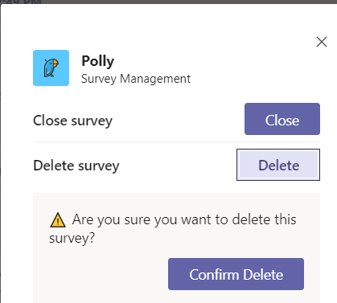
  - Screen will confirm survey was deleted
  - Click “Done”
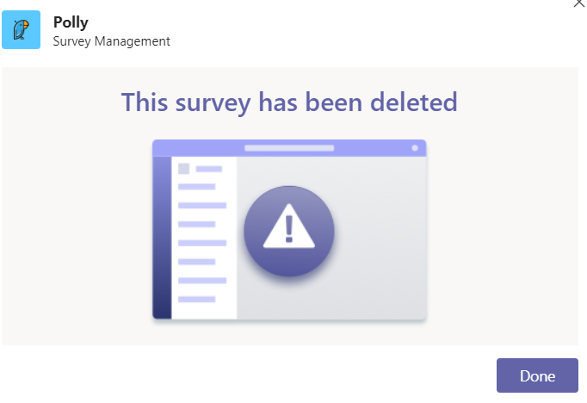
- Closing A Survey
  - Click “Close” button
  - Click “Confirm Close”
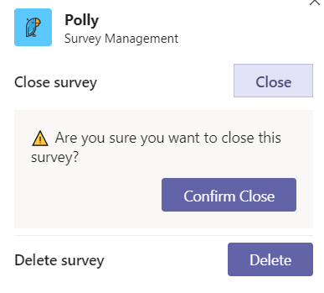
  - Screen will confirm survey was closed
  - Click “Done”
