How to Use Polly for Polls
- Polly needs to be added as an app
- In your team Click to add another tab (+)
- Click on the Polly app
- Click “Add”
- You are ready to create Polls
- In the Posts channel of the General Section, at the bottom you will see a Polly icon (this will be the same for any chat channel you create)
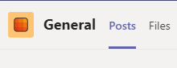
- Click on the Polly icon (looks like a parrot). This is done each time you need to add a poll.
- A screen will pop up
- You can choose if you want a Poll or a Survey
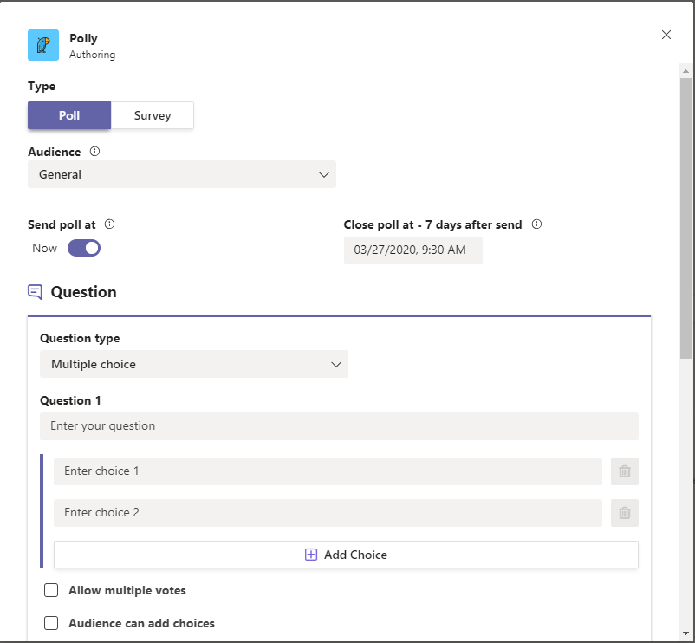

Polls

- Choose when you would like to send it
  - You can choose now (default as below screen)
  - Or Schedule a Start date and time. Click on the slider by Now

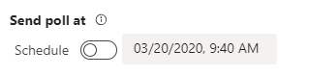
  - Here you can schedule the date and time you want it to start
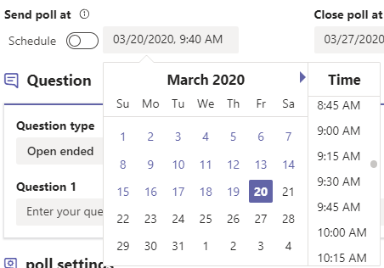

- Choose and End date and time

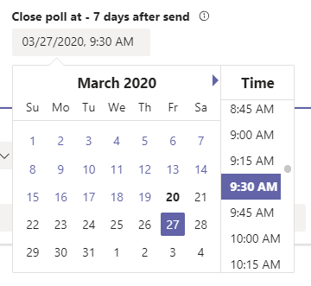
- Next Choose the Question Type
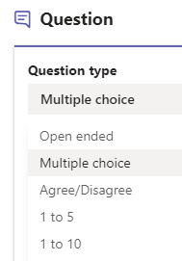
  - Open Ended Question Type
    - Choose the Result Settings for the question and the Audience Settings for the question
    - Click “Preview”

    - Here you can “Edit” or Send it to the Team
    - Poll is posted in the General channel
    - Members can now “Submit response”. Enter your response and Submit

    - Depending on Result settings you set, you will see responses

  - Multiple Choice Type Question
    - Type in your Question, type in the choices
    - You can “Allow multiple votes” and / or allow “Audience to add choices”
    - Default there are 2 lines for choices, Click “Add choice” to add more choices
    - Can also allow comments or not
    - Result settings and Audience Settings as a.i (above)
    - Click “Preview”
    - Click “Send”
  - Agree/ Disagree Type Question
    - Same as Open ended Question except can add comments or not
  - 1 to 5 Type Question
    - Type in a question and the members can select 1 – 5.
    - Members make their choice and “Submit Vote” and / or “Add Comment”. This is what the result will look like

  - 1 to 10 Type Question
    - Same as 1-5 question
    - Here members click on the drop down and choose number 1-10
- Members make their choice and “Submit Vote” and / or “Add Comment”. This is what the result will look like
- Deleting A Poll
  - Click the “…” next to the Poll you would like to delete
  - Click “Delete” button
  - Click “Confirm Delete”
  - Screen will confirm poll was deleted
  - Click “Done”
- Closing A Poll
  - Click “Close” button
  - Click “Confirm Close”
  - Screen will confirm poll was deleted
  - Click “Done”

