How to Share screens or Take Control
To share your screen in a meeting, select Share in your meeting controls. Then, choose to present your entire desktop, a window, a PowerPoint file, or a whiteboard.
Note: If you're using Teams on the web, you'll only be able to share your screen if you're using Google Chrome or the latest version of Microsoft Edge.
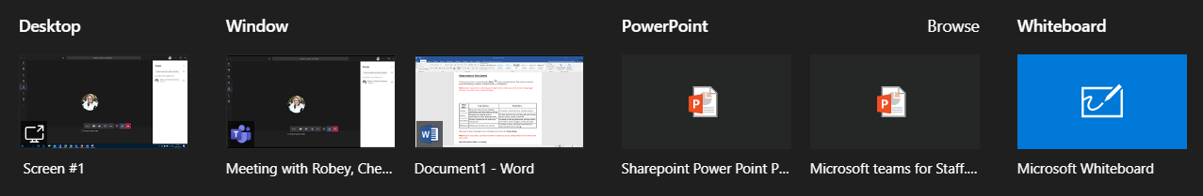
Share your... | If you want to... | Great when...
Desktop | Show your entire screen, including notifications and other desktop activity | You need to seamlessly share multiple windows
Window | Show just one window, and no notifications or other desktop activity | You only need to show one thing and want to keep the rest of your screen to yourself
PowerPoint | Present a PowerPoint file others can interact with | You need to share a presentation and want others to be able to move through it at their own pace
Whiteboard | Collaborate with others in real time | You want to sketch with others and have your notes attached to the meeting
When you're done sharing, go to your meeting controls and select Stop sharing
Note: If you're using a Mac, you'll be prompted to change your privacy settings before you're able to share your screen.
Give and take control of shared content
Take control
Note: The person has to share their desktop before you can request control.
To take control while another person is sharing, select Request control.
Then, the person sharing will approve or deny your request.
While you have control, you can make selections, edits, and other modifications to the shared screen.
You can see two different mouse pointers, your own and the person you gave control too
When you’re done, select Cancel control to stop sharing control.
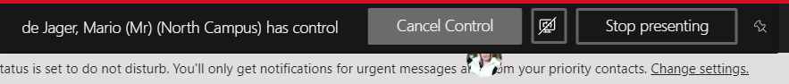
Give control
If you want another meeting participant to change a file, help you present, or demonstrate something, you can give control to that person. You will both be in control of the sharing, and you can take back control anytime.
On the sharing toolbar, select Give control. (right on top of the page you hover the mouse on the red bar)
- Select the name of the person you want to give control to.
Teams sends a notification to that person to let them know you’re sharing control. While you’re sharing control, they can make selections, edits, and other modifications to the shared screen.
- To take control back, select Take back control.
Zoom in to shared content
Want to get a better look at shared content?
Click and drag to see different areas.
And to zoom in or out, try the following:
- Pinch in or out on your trackpad
- Use the keyboard shortcuts Control + Plus sign and Control + Minus sign
- Hold the Control key and scroll with your mouse

