Setting up a Teams Webinar
- Go to your Calendar in TEAMS
- Click on the down arrow next to “New Meeting”
- Click “Webinar”
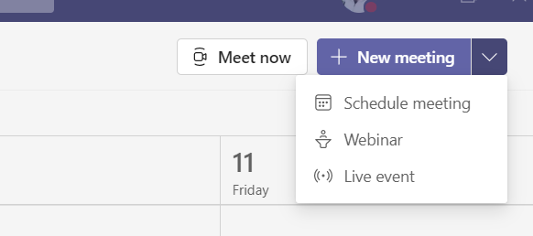
- Put in the Title / Name of the webinar
- Add the required presenters. You can add external presenters by adding their email address
- Date and time (From and to)
- And any detail for the webinar you would like
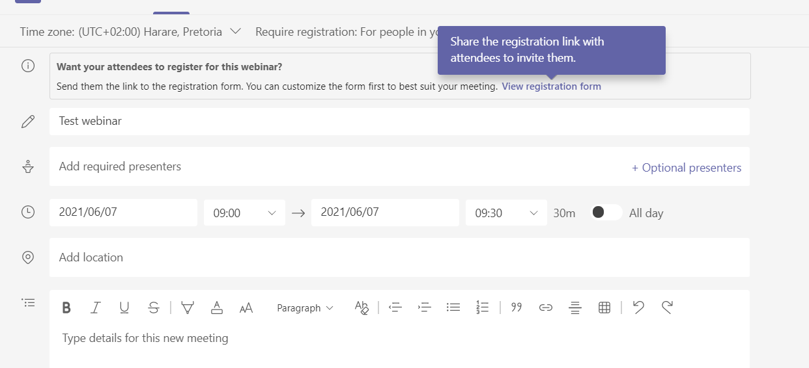

- Right on top you will see you can add a registration form and who you want to register using a registration form
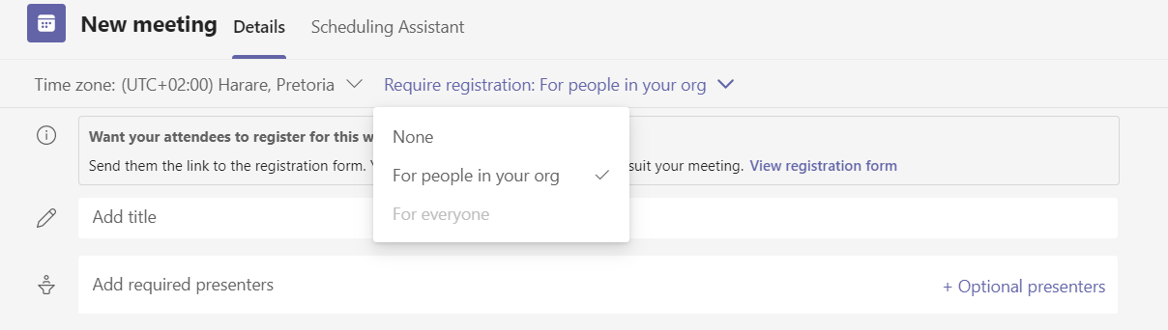

- Click on “View Registration form” to customize the form

- You will be able to customize the registration form by adding a Title, date and time of event, description of event, add who the speakers are and any extra fields you would like. You can also upload an image.

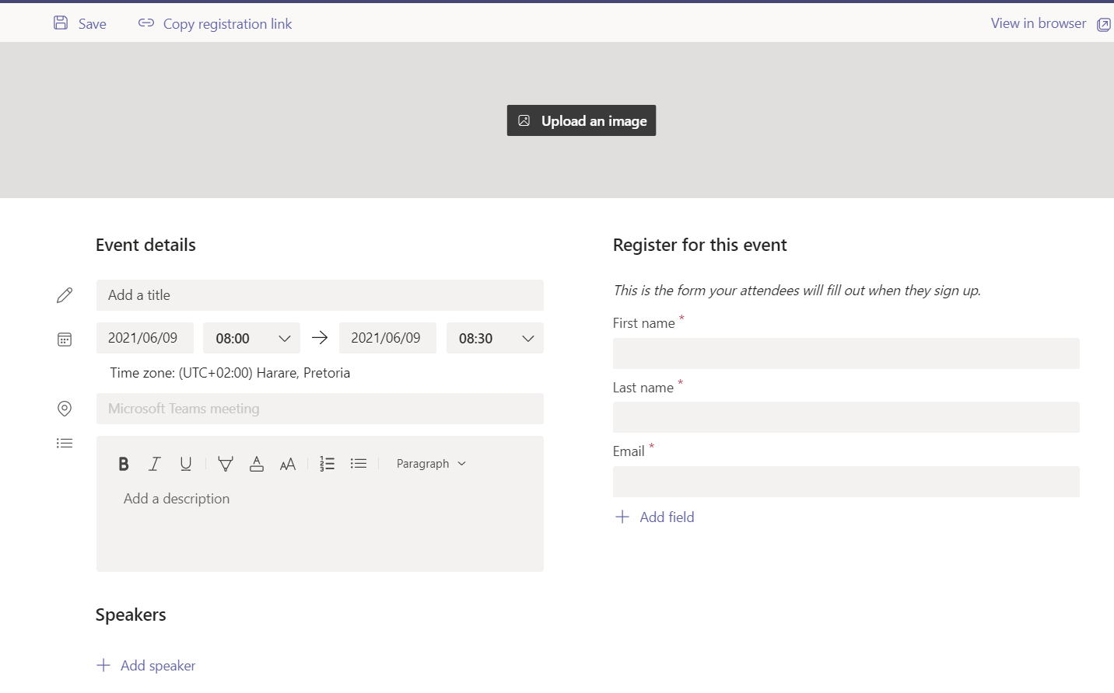
- To add extra field i.e. email address, Click on “Add Field”

- A pop up comes up
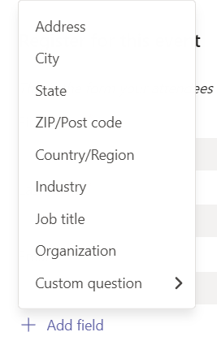
- To add a custom question click on “Custom question”

- Choose if you want them to input something or to choose from a list you give them (choice)
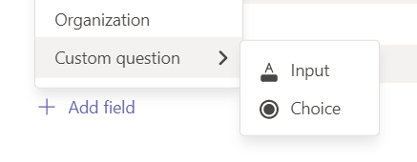

- For email address we will choose Input
- Below is what you will see for Input
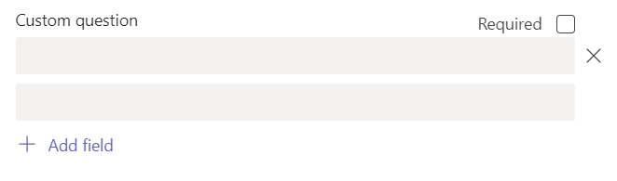
- Type the question and if you want it to be a required field, check the check box
- You can view what the user will see by clicking on “View in Browser” top right hand corner of the registration form.
- Copy the Registration link on the top left hand side for you invite or email that will go out

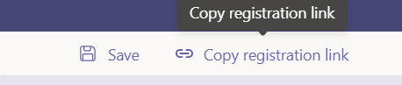

- Finally Click “Save” top left of the form

- You can go back and Edit the registration form

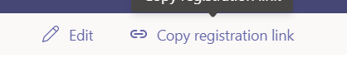

- Close the registration form by clicking the X on the top right hand corner

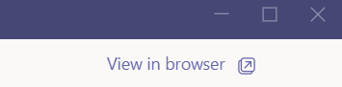

- Click “Send” (top right corner) which will schedule the event and send the invite out to the presenters
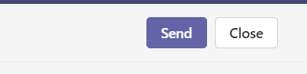
Editing the Meeting Options
- Click on your Webinar you have set up
- Click on Edit or the double arrow in the right hand corner
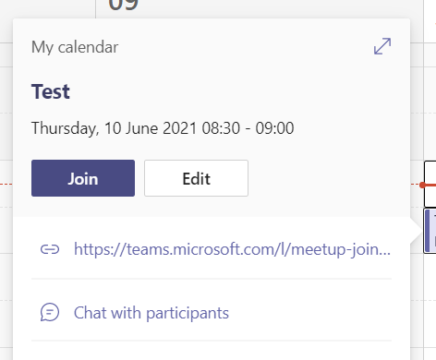

- Click on Change options. PLEASE NOTE – meeting options WILL NOT show in Internet Explorer. Please use another browser.
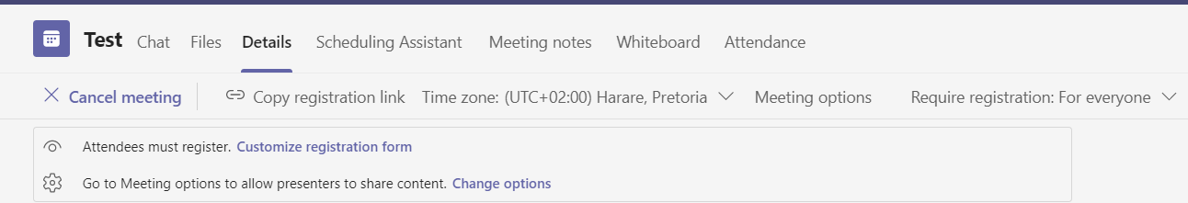

- Here you can change the settings for the Teams webinar
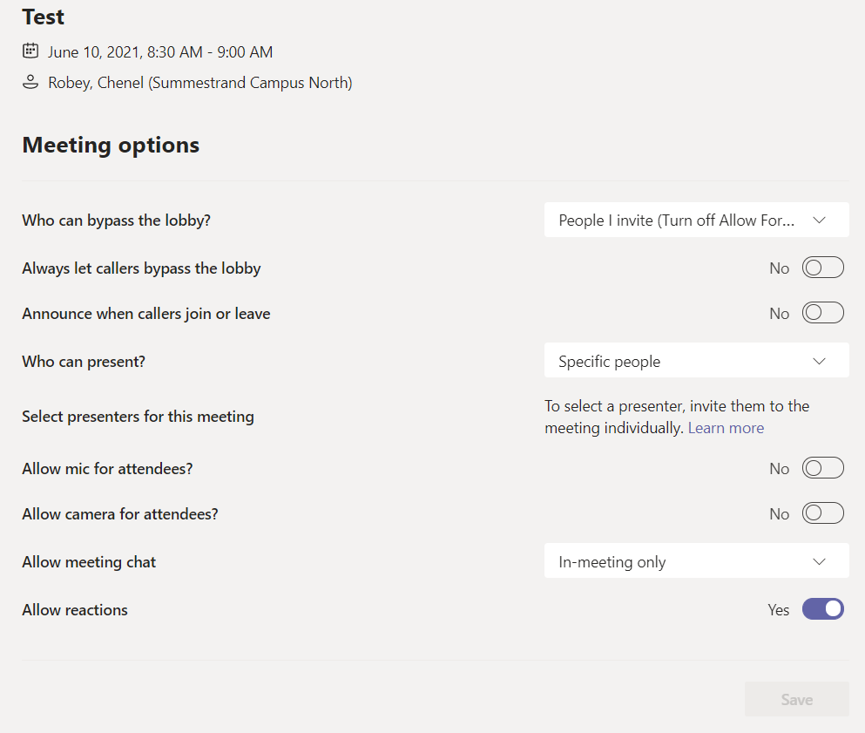

- Who can bypass the lobby - these are your options
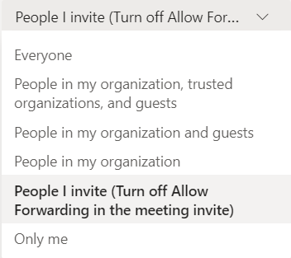
- Who can present – these are the options
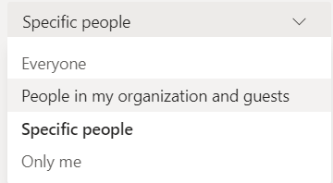
- Here you can turn the mic and video off of attendees when they enter.
- You CAN turn it on in the webinar if you want
- You also have ONE BUTTON to let all people in at the same time when they are waiting in the lobby
- The rest of the options are self-explanatory
- ONLY once you have chosen options (specifically who can present) will the SAVE button be available
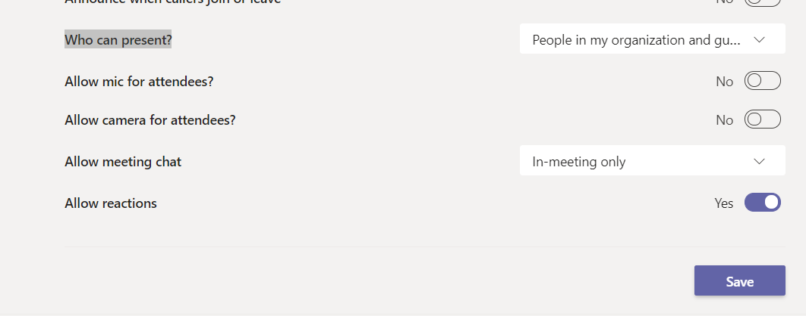
- Click Save
Registration Report
- You can download the registration report to see who has registered for the event
