How to Add a Guest (external user) to Microsoft Teams

- Team owners are able to Add a Guest

- Guests must have an Office 365 work or school account. If the guest doesn’t yet have a Microsoft account associated with their email address, they will be directed to create one for free.

- Guest permissions are limited to help protect your organization’s data. Guests can send messages to the team like any other user. They can also share files and create private chats. Access to most other features is restricted, so guests can’t schedule meetings, change Teams settings, create new teams or manage apps.

- Next to your team name you will find “…” click on it, then click on Manage Team
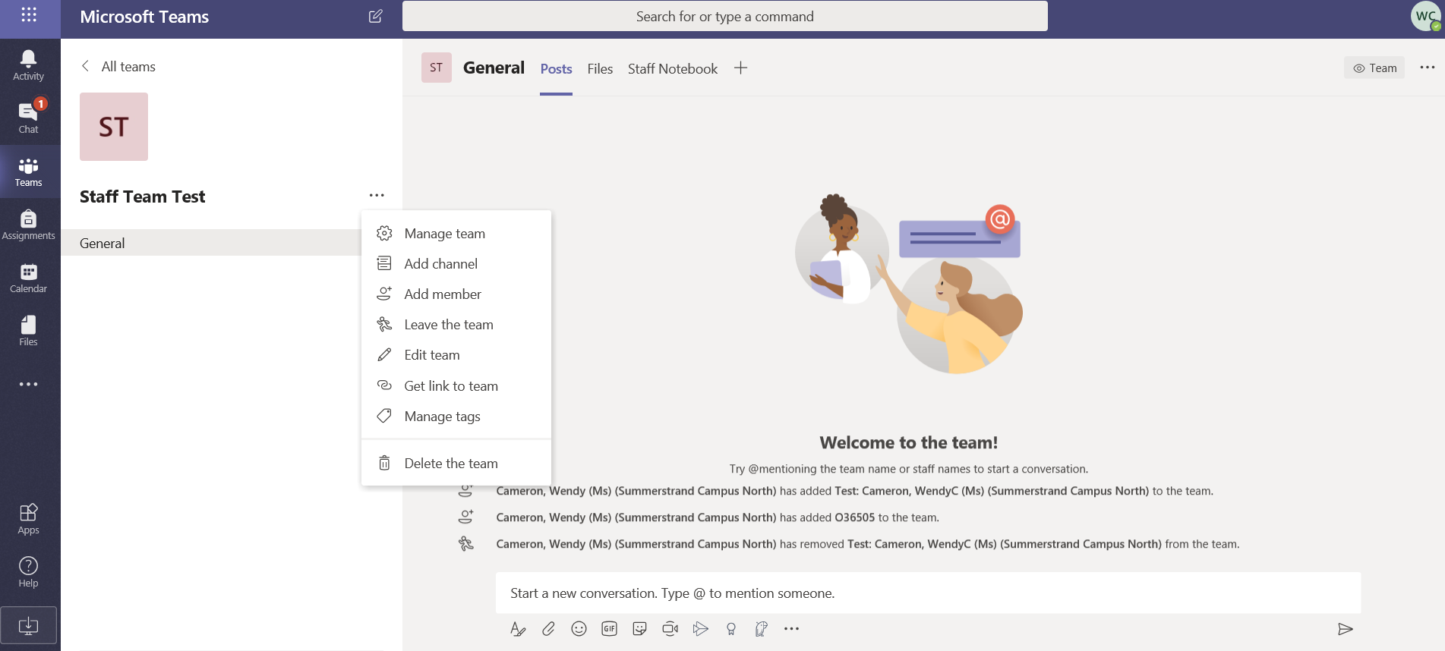

- Click the Add member button
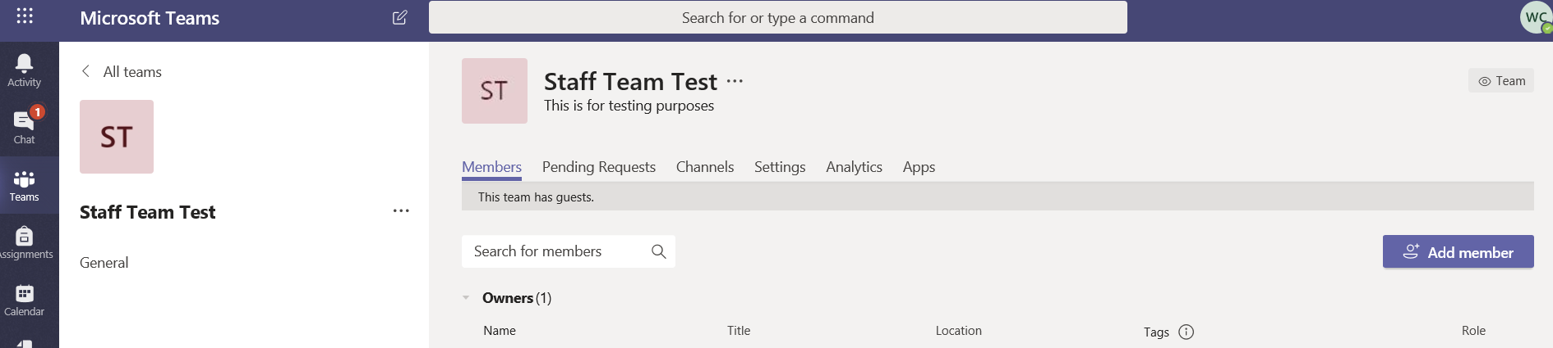

- Type the guest’s email address in the search bar. Once you completed the email address, you will be prompted to add a guest (you will see “Add Username@gmail.com as a guest). Click Add and Close.
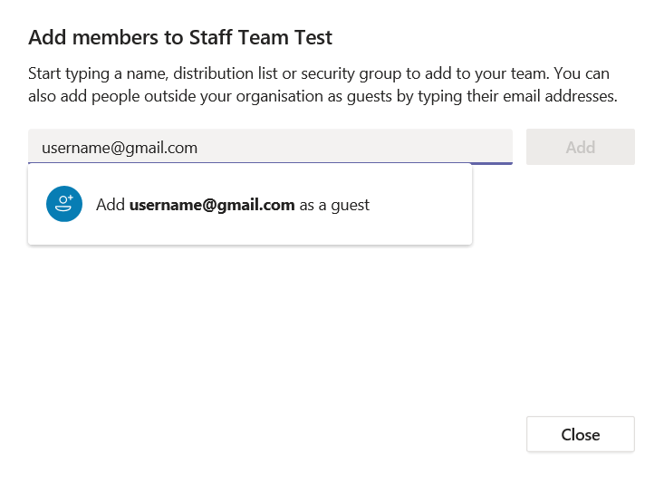
- The user is now added as a Guest to the Team.

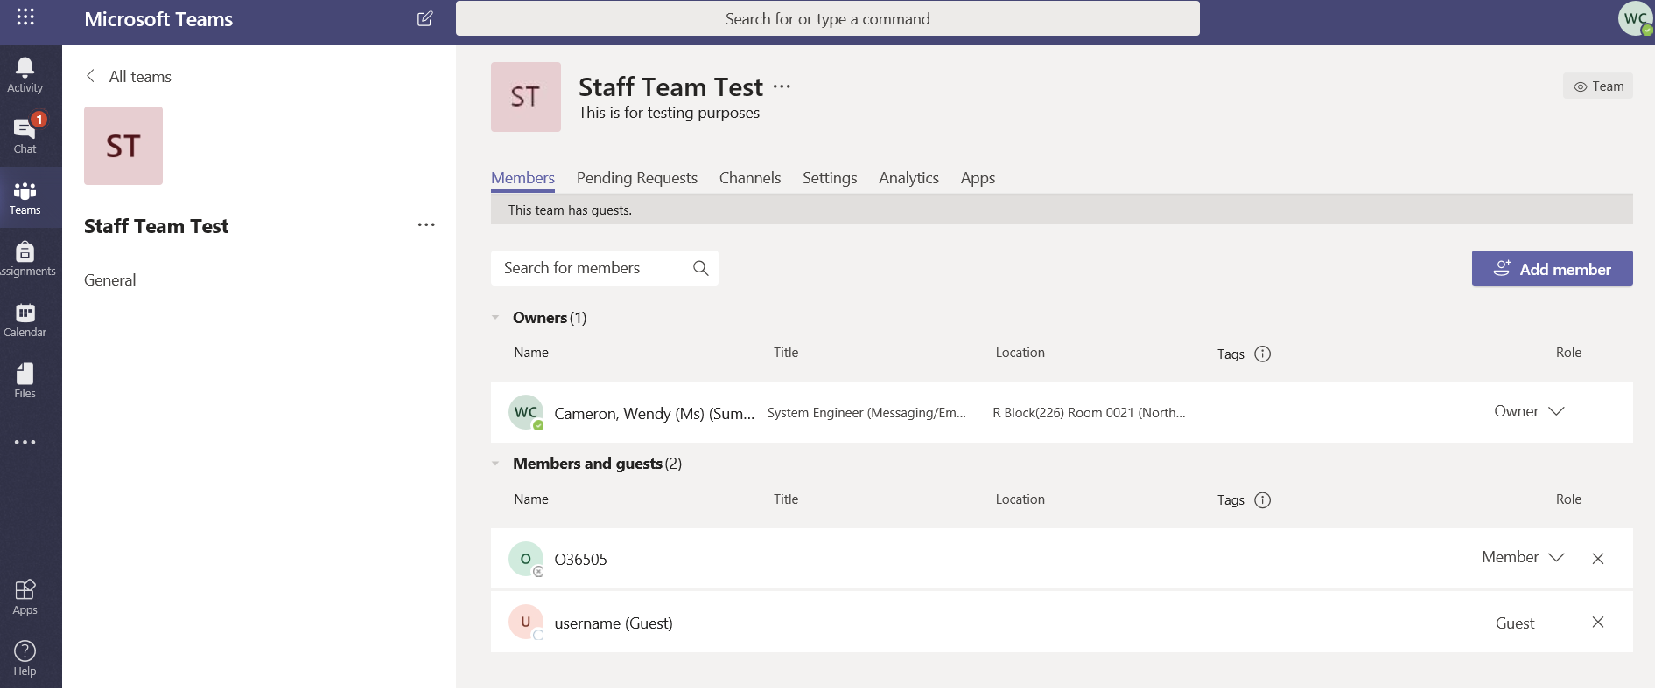

- An automated email will be sent to the Guest user to notify them that they were added to the Team. The email includes details on what the guest needs to do to view the Team, see example below.

