How to Add, Remove Members and Change Membership types in Microsoft Teams

- Next to your team name you will fine “…” click on it, the click on Manage Team
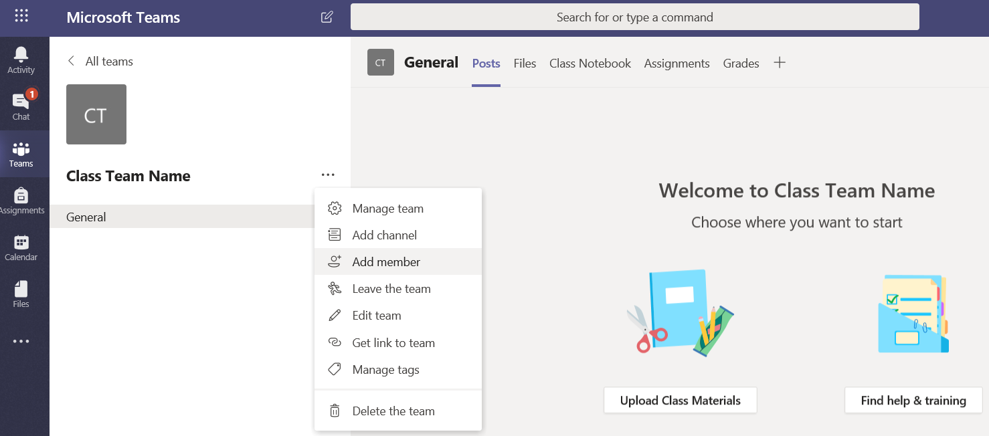

- Click on Add member button

- Select the Students and Teachers you would like to add. Click on Add and then click Close.
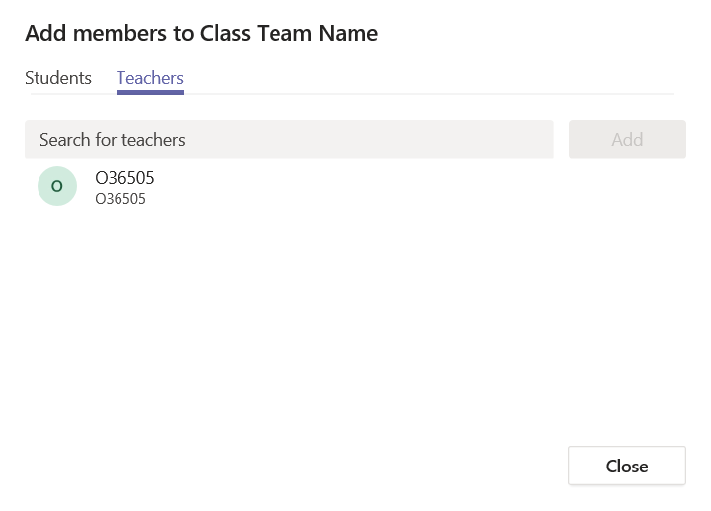
- Add a module code with all the students in. Type the module code and pick it from the list. Click “Add”

- You need to accept that you adding all “30 members” (the amount of members will show up in red under the module code name)

- Once you click on the “tick” it will add all the members to the Team Site

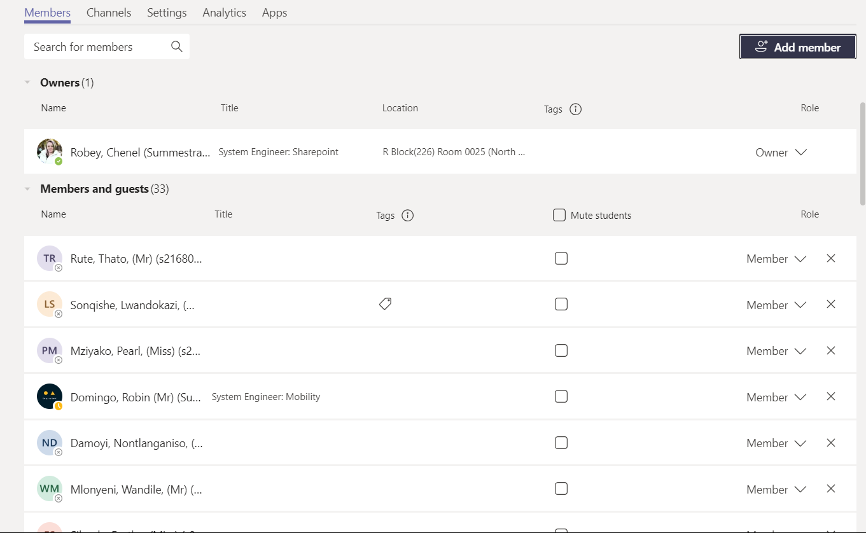

- See members added below. Note for Class Teams all students are listed as a member and all Teachers will be listed as an owner

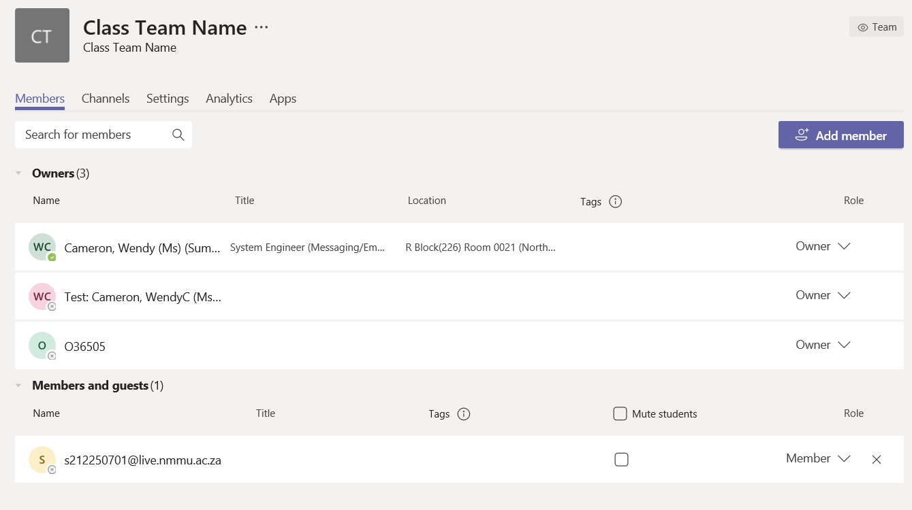

- On Staff Teams you can follow the same procedure from point 2, however when selecting users to staff teams it gives you the option to make that user an Owner or a Member. Select your preference and click Close.
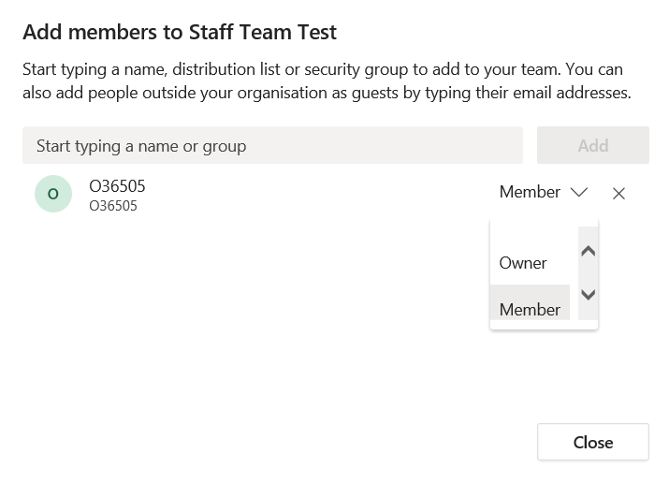
- Under the Manage Team option you can change the settings from Owner and Member here. Click the down arrow next to the Role and select your preferred option.

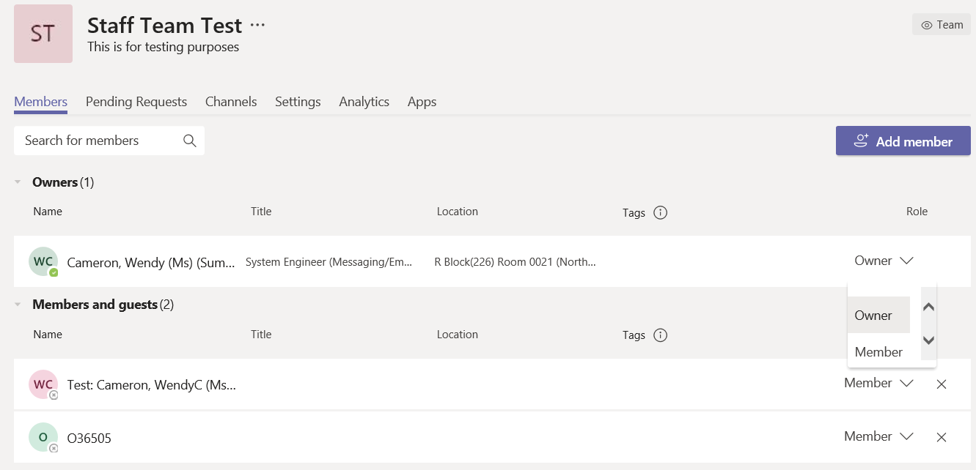

- To remove a member from a Team click on the ‘X’, next to the users role and the user will be removed. (If you hold the cursor over the ‘X” it tells you it will remove that member ‘Remove O36505’)

