Microsoft Stream How To
- As the meeting recording owner, go to the recording in the Teams chat history and select More options then Open in Microsoft Stream.
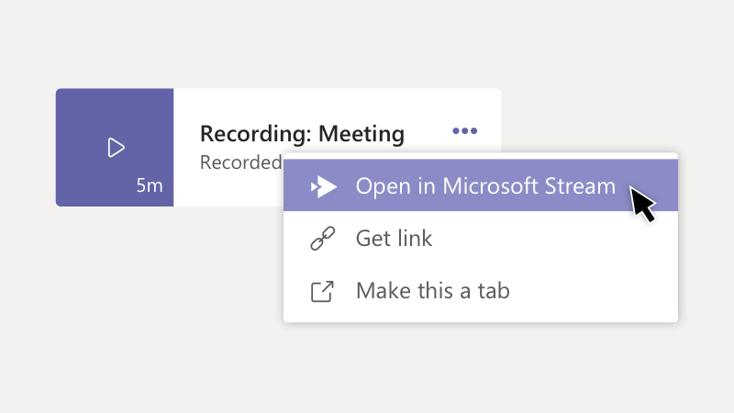
- Change the permissions for the video to allow groups or individuals to view it in Stream.
  - ONLY THE OWNER CAN DO THIS
  - In the Microsoft Stream portal, under the video, select then Update Video Details.
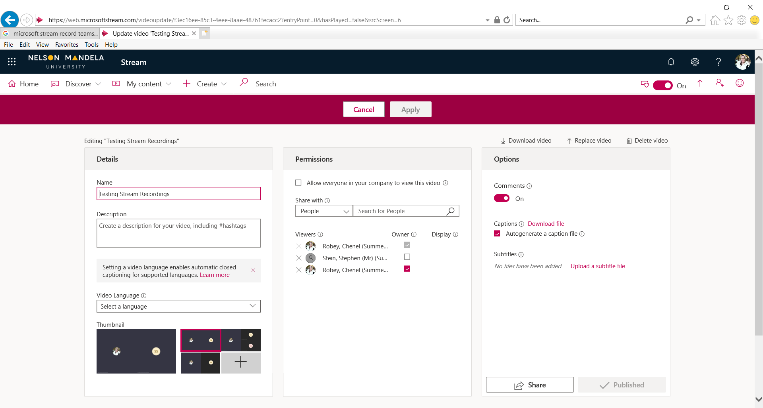
  - In the Permissions section, add people or Microsoft 365 groups who need viewer or owner access to the video. Here you can see who has access to view the video.
  - Allow everyone in your company to view the video is defaulted to NOT allow
  - IF you would like everyone to see the video tick the check box next to Allow everyone in your company to view the video
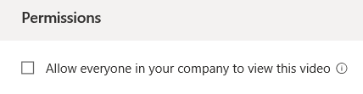
  - Viewers can only view, they can share HOWEVER if the person they are sharing with does not have access to view the video they WILL NOT SEE IT. They have to log in with their O365 credentials into OUR organization.
  - Viewers DO NOT have access to edit video details
  - As an owner (person who reordered the video) you can make another person an owner.
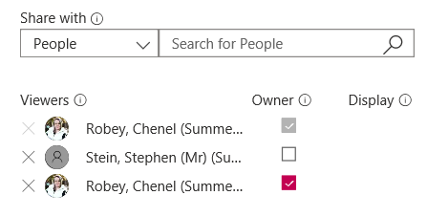
  - Owners can remove people, add people and change/edit details of video.
Download transcript file
- ONLY THE OWNER CAN DO THIS
- In the Microsoft Stream portal, under the video, select then Update Video Details
- On the right hand side of the screen under Options section there will be Captions > Download a file
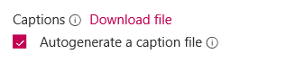
- This is the transcript file
Download or Delete Video
- ONLY THE OWNER CAN DO THIS
- In the Microsoft Stream portal, under the video, select then Update Video Details
- On the right hand side of the screen above Options section you will be able to download, replace or delete video
