How to install Office365 ProPlus from Home.

- Go to https://portal.office.com/
- Then Enter your username@mandela.ac.za then click Next
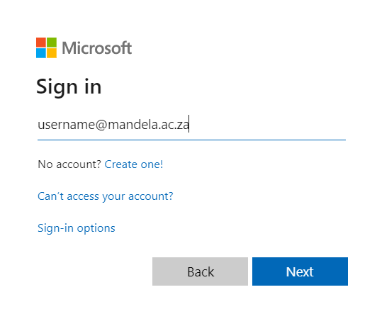
- A pop up dialog box will come up (Please enter username@mandela.ac.za and the password then click Ok)
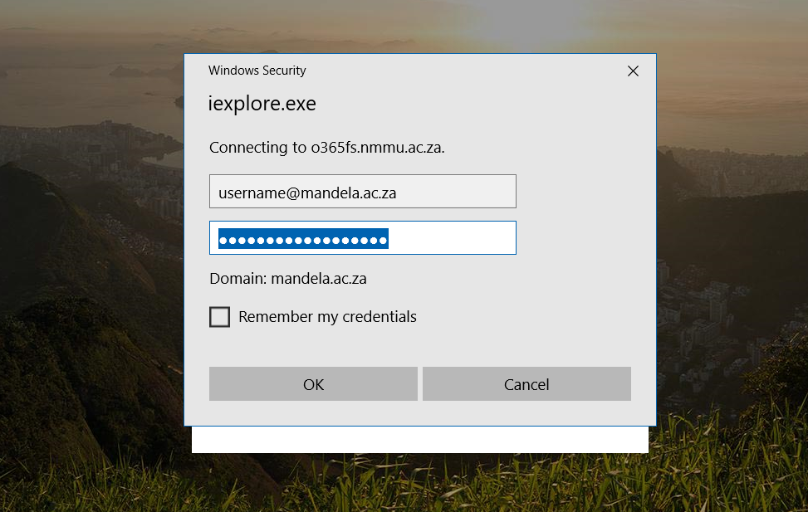

- Click on Install Office as shown below
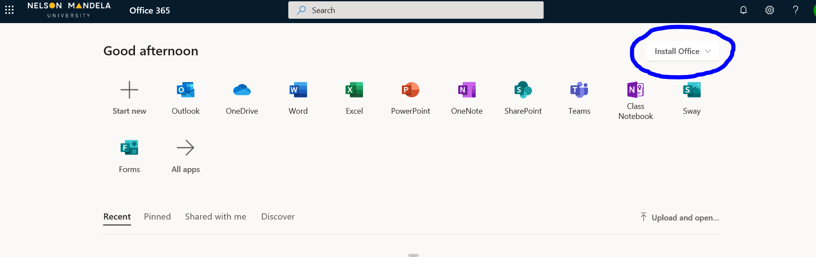

- Choose Office 365 Apps
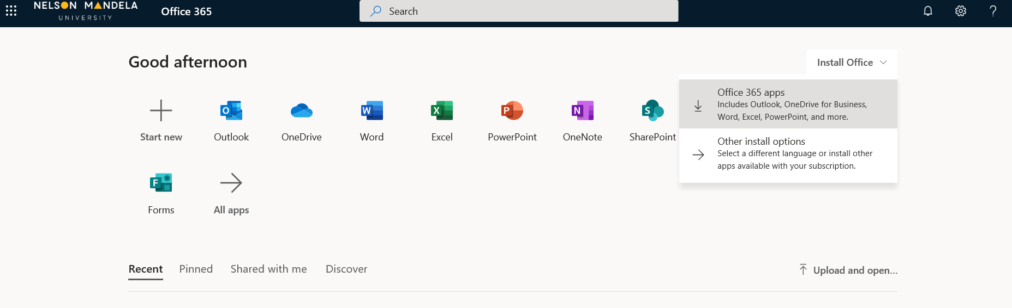

- A Pop Up Window will appear at the bottom of the screen, Click Save
- Click on Run on the second Pop Up window which will appear at the bottom.
- Office will start installing
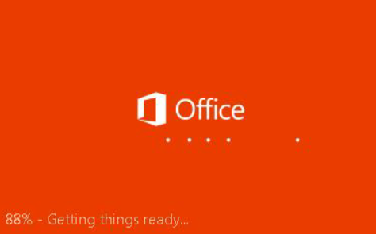

- Accept the Microsoft Office License Agreement, Click Accept
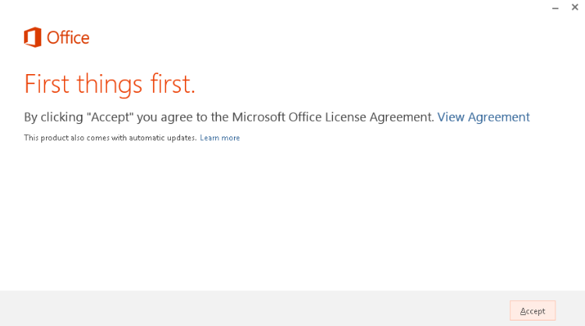
- While Office is Installing you will see this screen, a short Video will be played, please view the video, then click next
