To login to a sharepoint site:
The student will be asked to login to the sharepoint site as he/she is a registered student and he/she will have access to the subjects (sharepoint sites) automatically.
Go to the following web site and type in the relevant subject code.
https://livenmmuac.sharepoint.com/sites/RG301/
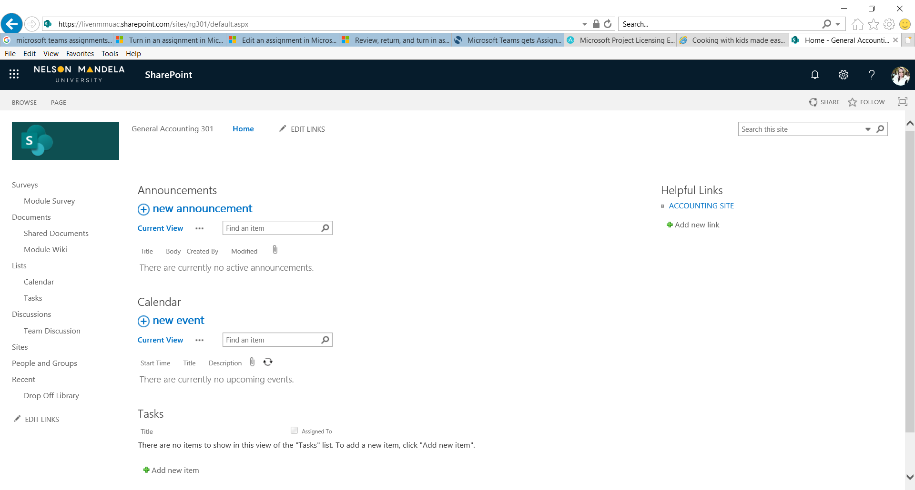

Type in the following web address and type in the subject code for the subject that you are registered for as
https://livenmmuac.sharepoint.com/sites/RG301/

Username – (student number)@mandela.ac.za – typed in as one word Password – the permanent password that the student has created or been given

