Create-and-Set-Signatures-in-Outlook:
- Click on File
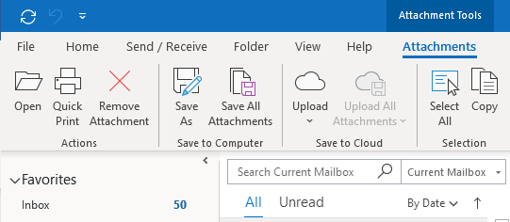

- Click on Options
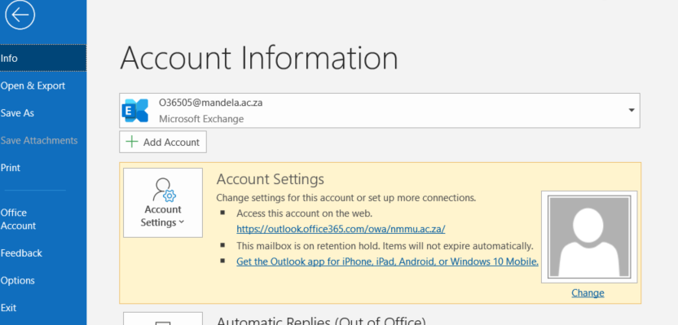

- Click on Mail and then Signatures
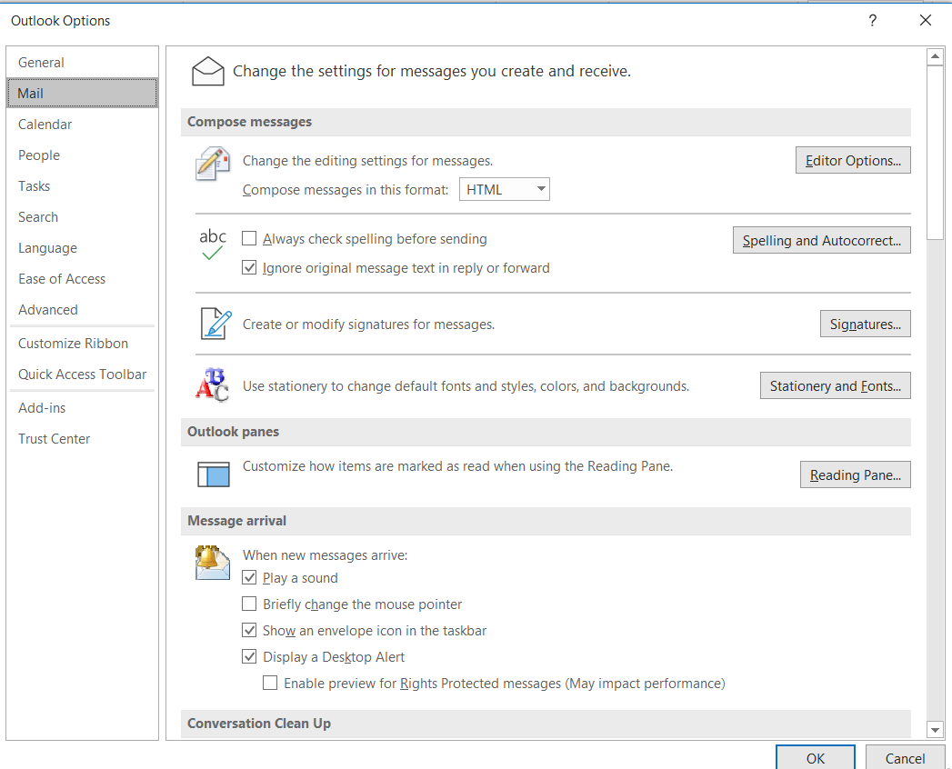
- Click on New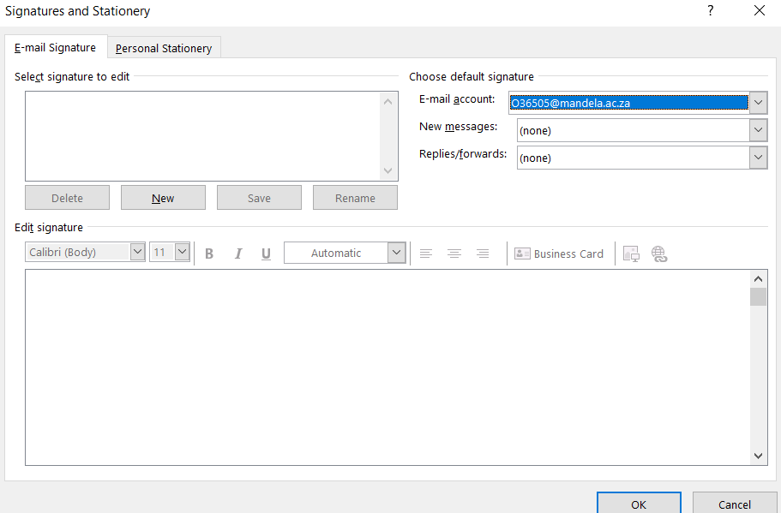
- Type in the name of the signature (Eg. Can be users FirstName) and click Ok
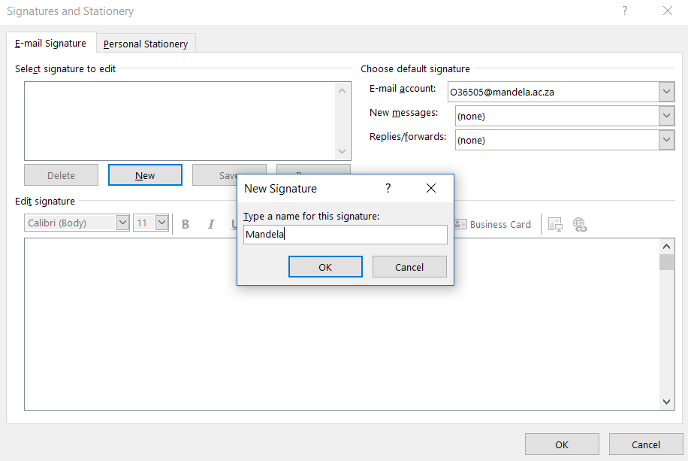
- Create the signature. Please note that the institution has a corporate signature that you must use, see link : https://corpid.mandela.ac.za/E-mail-signature

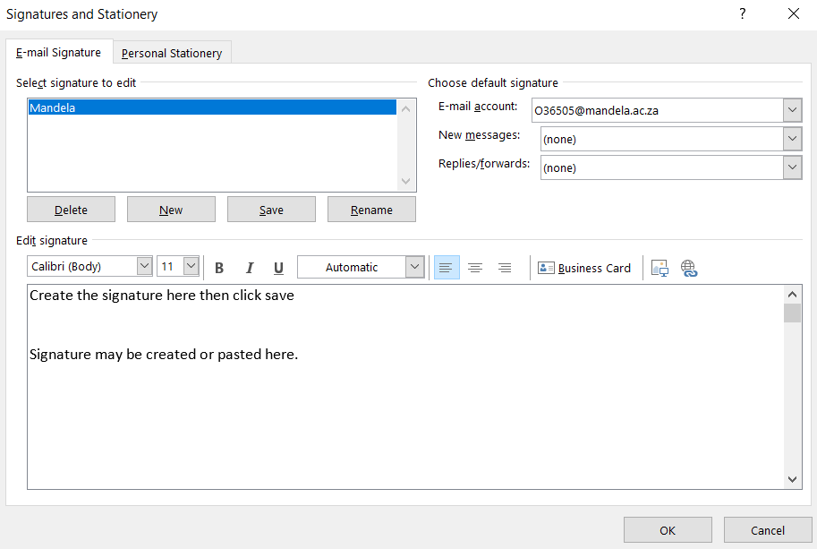
- Please make sure that you select the signature that you created as your default in the section shown below then click ok.
