How to reduce noise in MS Teams
Video to watch on how it reduces the noise https://www.youtube.com/watch?v=DMtWR-SQd68
- Click on your profile picture or where your initials are in the top right hand corner of MS Teams
- Click on Settings
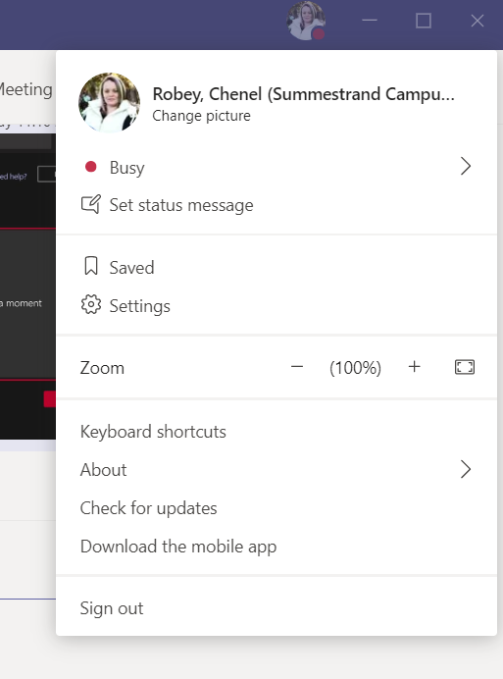
- Click on Devices on the left hand side column
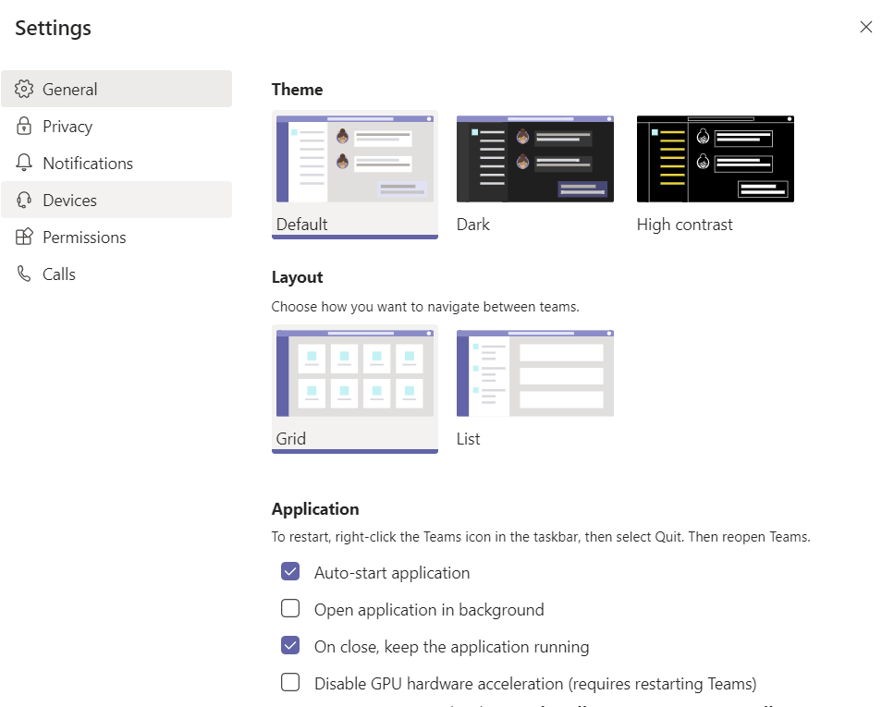

- Here you will see “Noise Suppression” heading
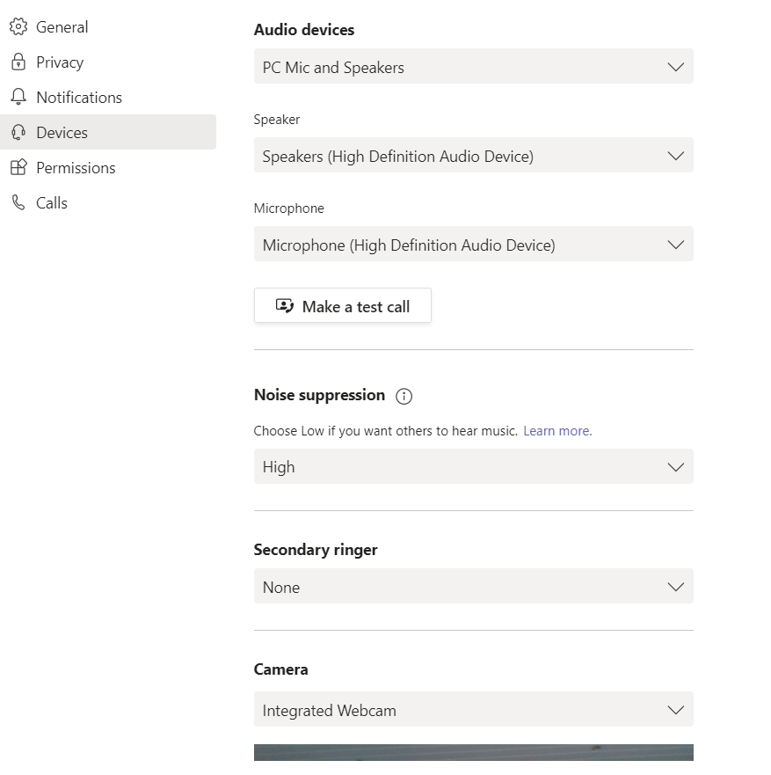
- Click on the drop down and change to High
