How to Schedule a Meeting using Teams in Outlook

- Teams has to be installed on your device and it has to be restarted for this to appear in your Outlook
- Speakers or headphones is a MUST to be able to hear what is being said in the meeting. Please NOTE most laptops have built in speakers and microphones. If you have a webcam on your PC there will be a microphone built into it.

- Click on the New Items and then Teams Meeting right at the bottom of the drop down list

- Here you can schedule the meeting at the date and time required, enter the people required, the Subject and any content.
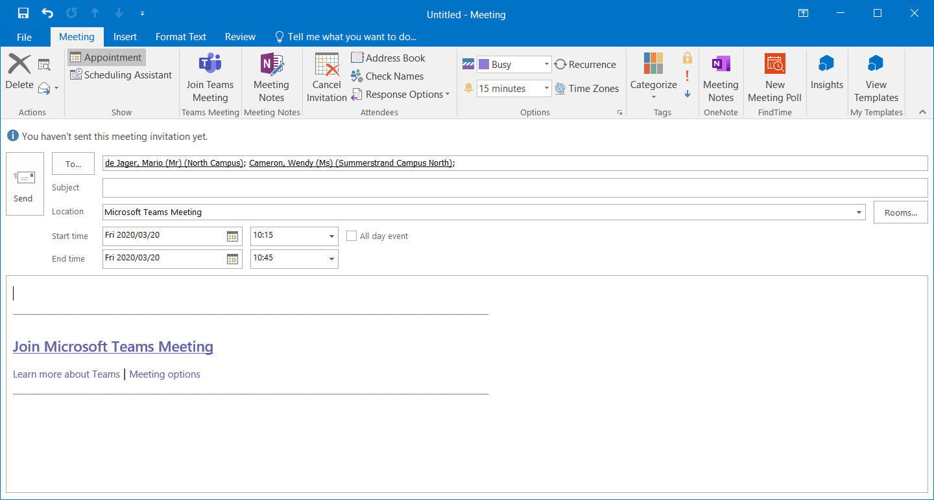
- It will look like a normal meeting request in your outlook calendar, when you need to join the meeting you can do it in 2 ways from outlook.

- Either by clicking the “Join Microsoft Teams Meeting” link in the email
Or by Clicking “Join Teams Meeting Now”
- A screen will open in Teams and you click on “Join Now”
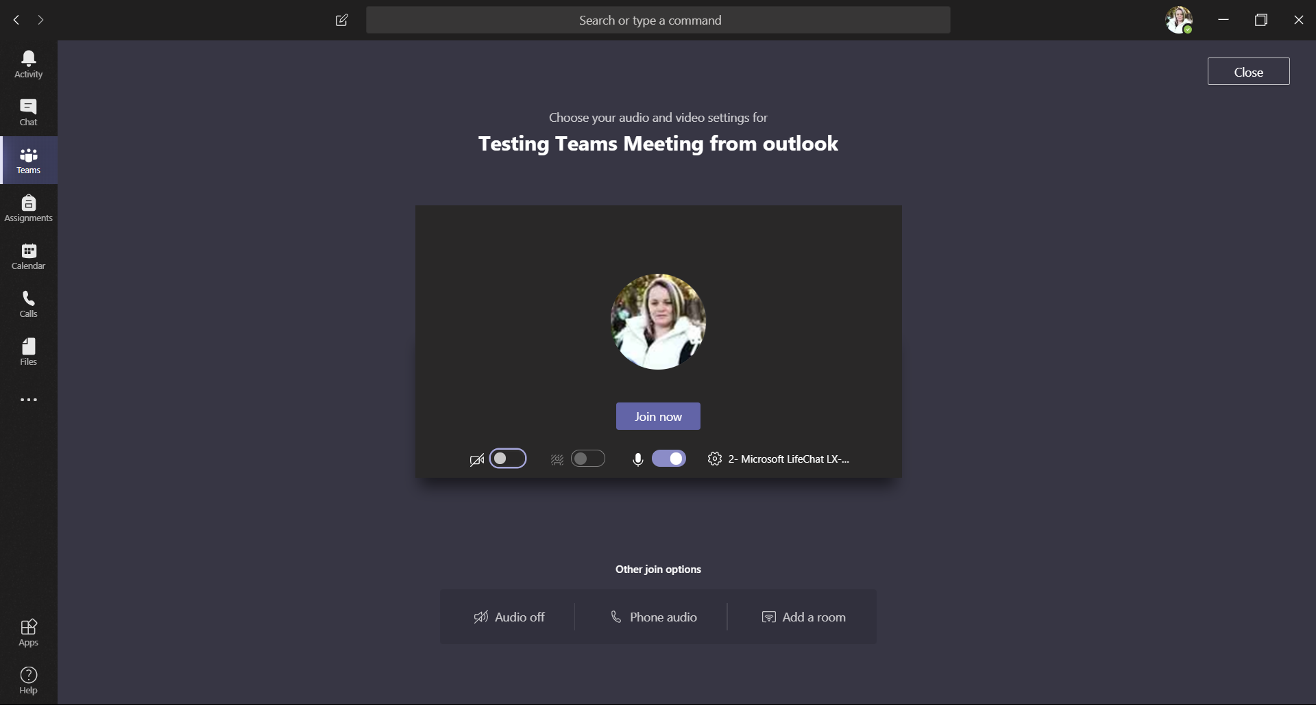
- If your microphone is not working, make sure the microphone is on and Click “Audio Off” (if you have not joined the meeting it will join you now)
- Please click “Turn audio on” button to turn on your microphone

- If you would like to see who has joined or who needs to still join click on “Show participants” button
- Here you able to see everything on the right hand side of your screen
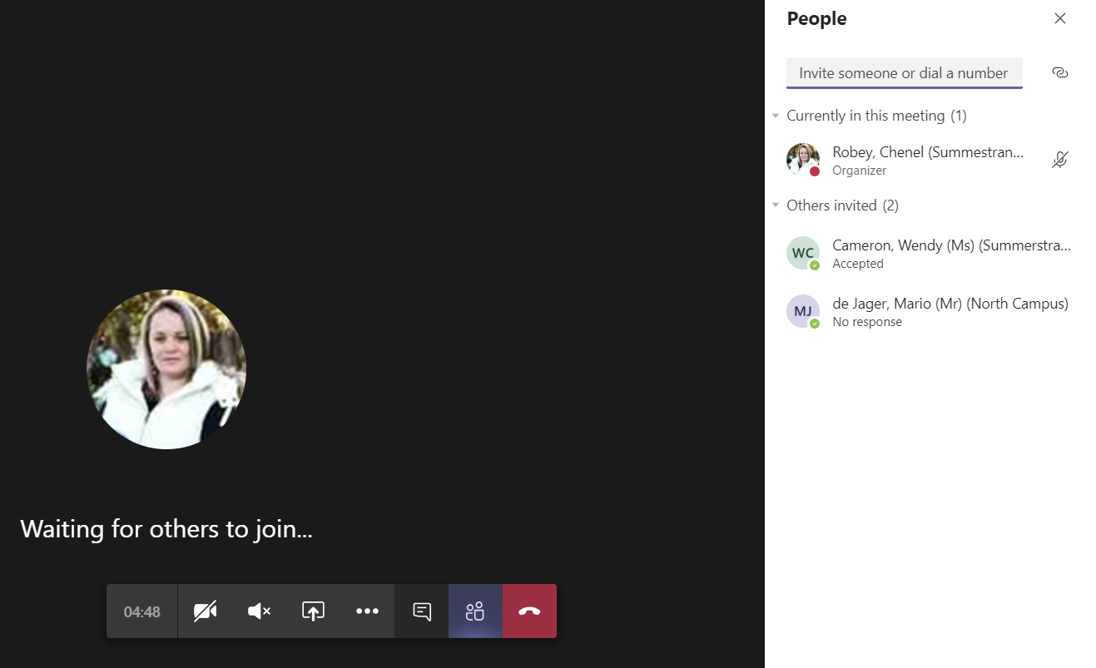

- You can type in the chat window to communicate. Click on “Show conversation” button
- Now you able to type in the meeting (will pop up on the right hand side of the screen)

- Ending a call, click on “Hang up”, the red button

