How to do Assignments in Teams
- Click on Assignment tab and Click Create (to create a new assignment)
- A menu will pop up, click Assignment
- Here you fill in the details you want for the assignment.
  - Enter Title
  - Enter the instructions on what the students must do
  - Add any resources you want the students to have a look at (can be files from your onedrive, Teams or a new file)
  - Enter the points they will get for this assignment
  - You can assign to individual students or All students
  - Choose the due date and you can also choose the time it must be in by.

  - You can also allow late turn ins (date and time)
- After all the information is inputted the Assign button will become available.
  - Click Assign to push the assignment to all students
  - You can Save the assignment and edit later before Assigning it to the students
  - Or you can Discard the assignment
- Assignment pops up in Assigned. Please wait for the Assignment to be “pushed” to all students. It will tell you when it is finished. You are able to see how many assignments have been assigned.

- This is what the student will see
  - Students Add work and Click on the Turn in button

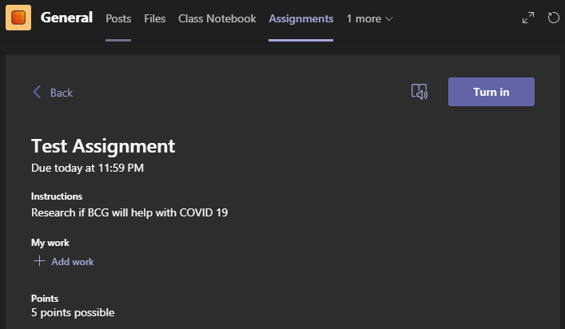

- After the student turns in their work this is what they will see
  - They can undo their turn in (Click Undo turn in button)

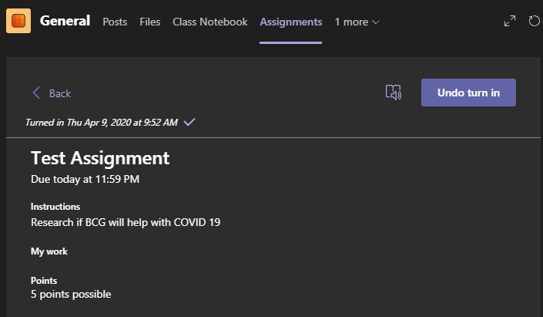

- Below are the options for turning in the students work
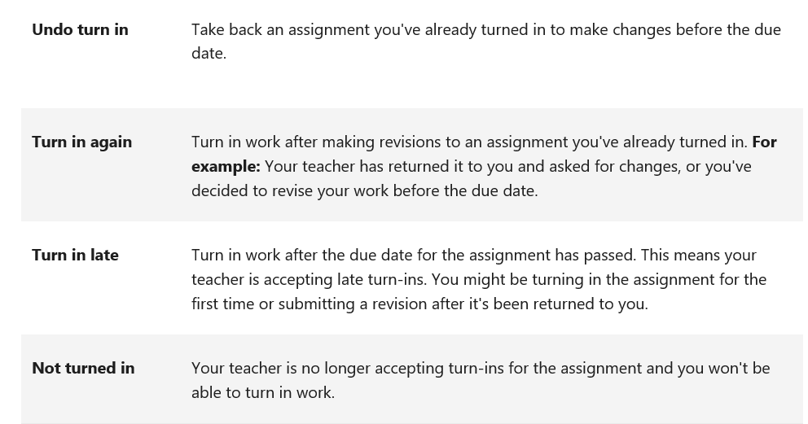
- For the lecturer again, Click on the Assignment to see the students who have turned in and the status of the assignment (graded or not)
- Here you will see which student has turned in their assignment. Click on Turned In to view the students work

- You will see what the student has submitted
  - Enter Feedback (if any) for the student
  - Give points accordingly
- Click on Return
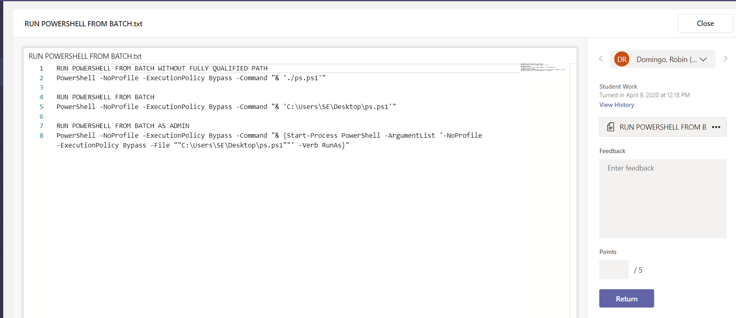

- The assignment goes back to the student to see their points allocated for the assignment and the feedback
- Click Close
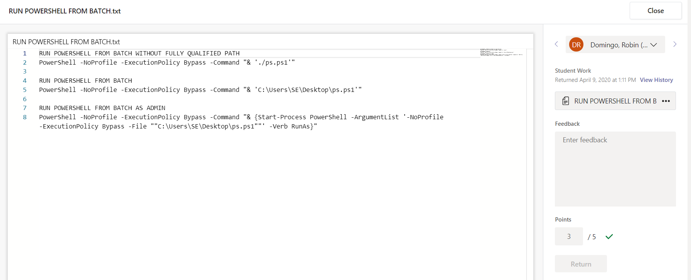

- You will be able to see which assignments need to be graded and which are graded
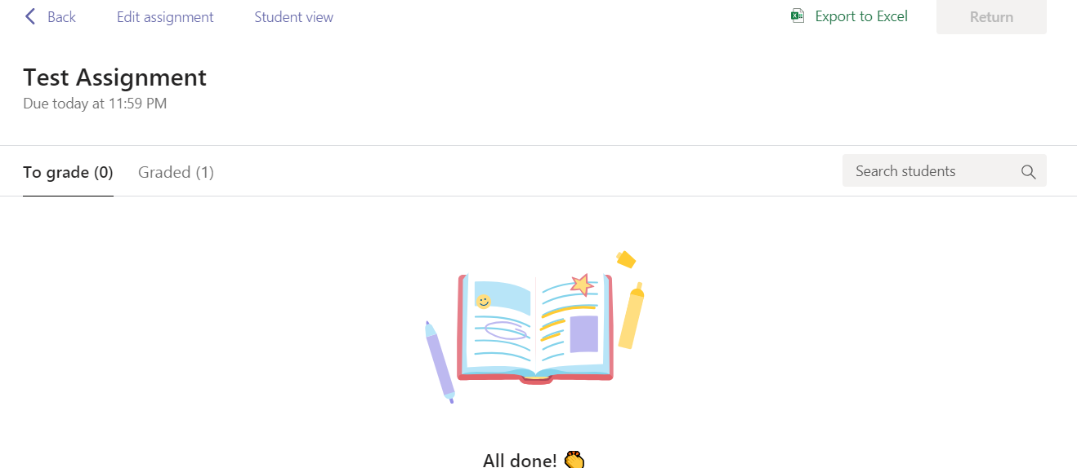
- Click on Graded to see the students whose work has been graded
- This can be exported to Excel

Grades
- Click on the Grades tab
- You able to see all the assignments that were given and all the students points (if they were graded)
- Below is what you will be able to see
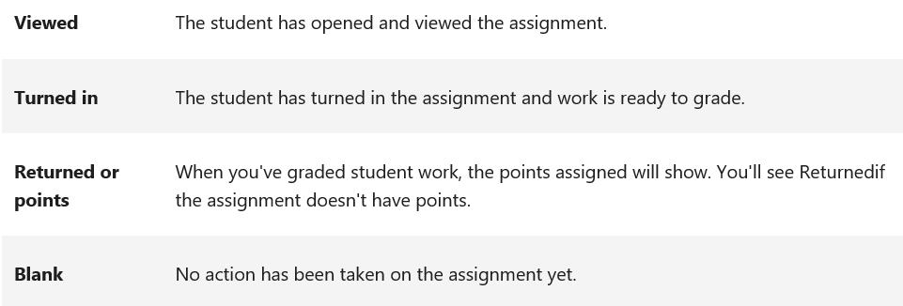
- If their work is not yet graded but they have turned it in you will see a Turned In button
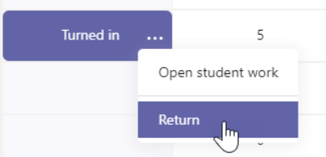
- Click Open Student Work or Return (if you have already looked at the students work) and you can grade the work
- This can also be Exported to Excel