How to Create a Microsoft Team
- Once logged into Teams make sure you are on the Teams option. Then click on the Join or create team button
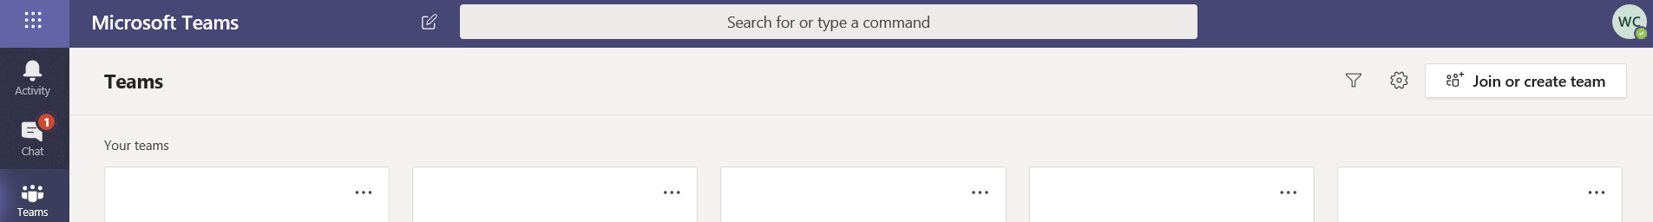

- Click on Create Team
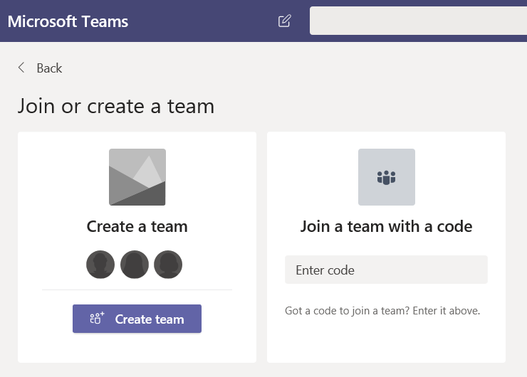

- Note there are 4 Types of Teams that can be created, we are going to concentrate on Class and Staff teams for now. Select Class
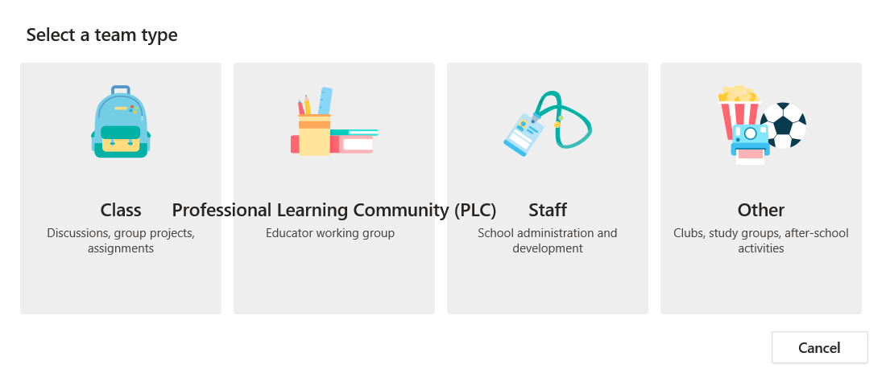
- Enter your Team name and a brief description of the team below, the click on Next
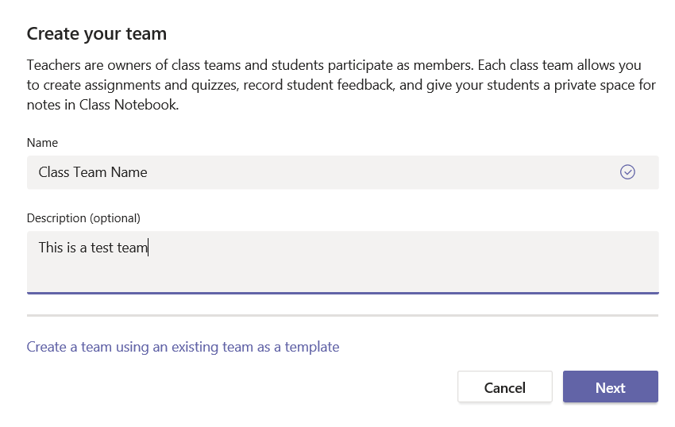

- On the Students tab you can select the users you want to add to the Team. Type the name in the search bar and click on ADD. You can do the same for the Teachers Tab. Once all users are selected click Close.

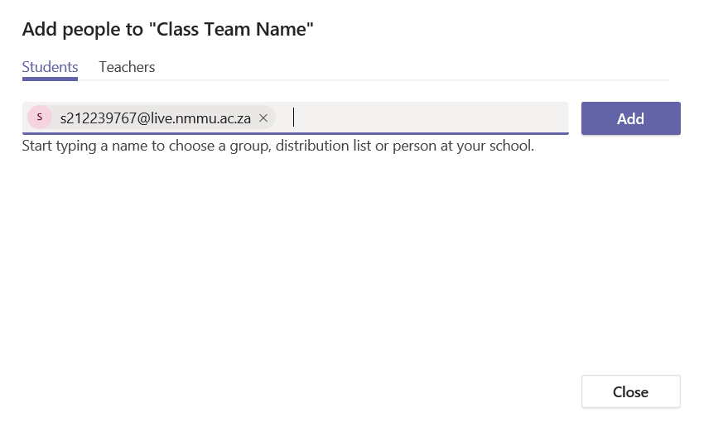

- Add a module code with all the students in. Type the module code and pick it from the list. Click “Add”

- You need to accept that you adding all “30 members” (the amount of members will show up in red under the module code name)

- Once you click on the “tick” it will add all the members to the Team Site

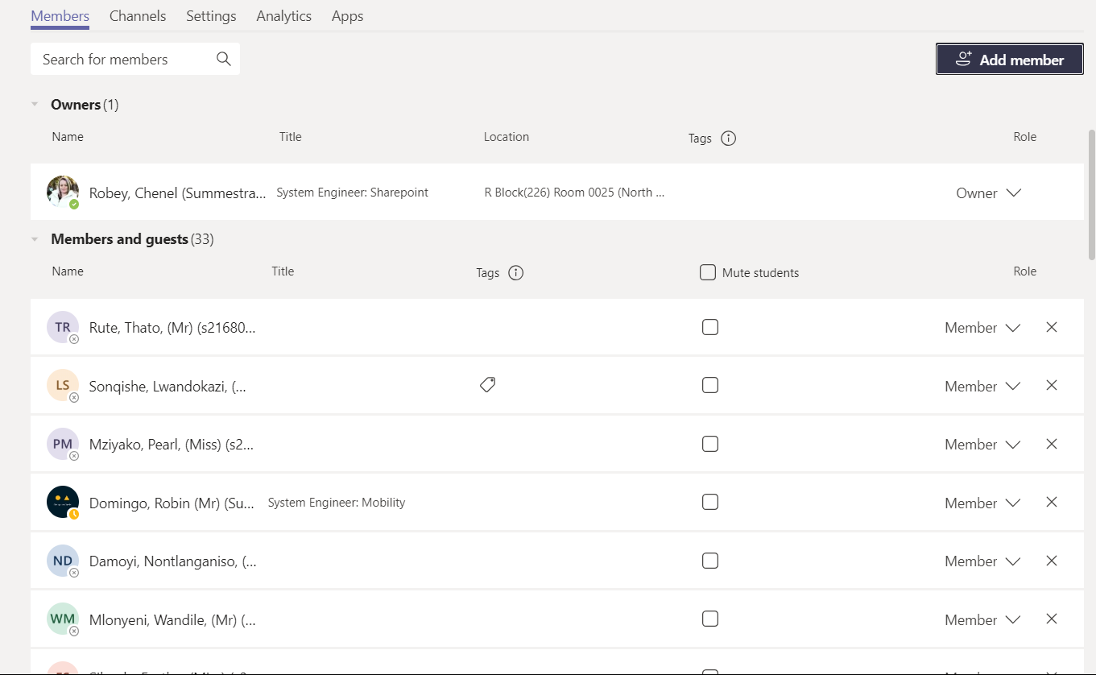

- You will then see your newly created Class Team 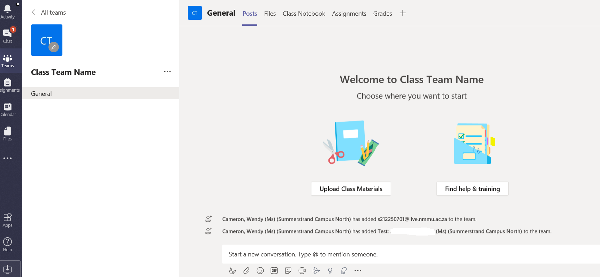

- If we selected Staff Team in point 3 this is what the settings would look like. Give your Staff team a name and description and select it to be private or public. Private option is recommended. Then click Next.

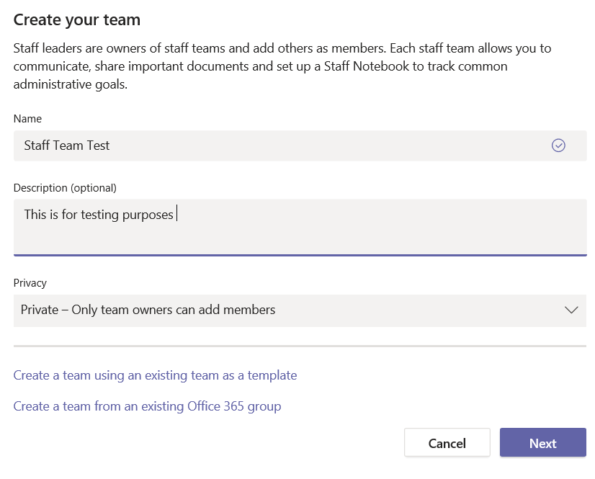

- Add users to your Team. Search for users, click Add and then click Close.
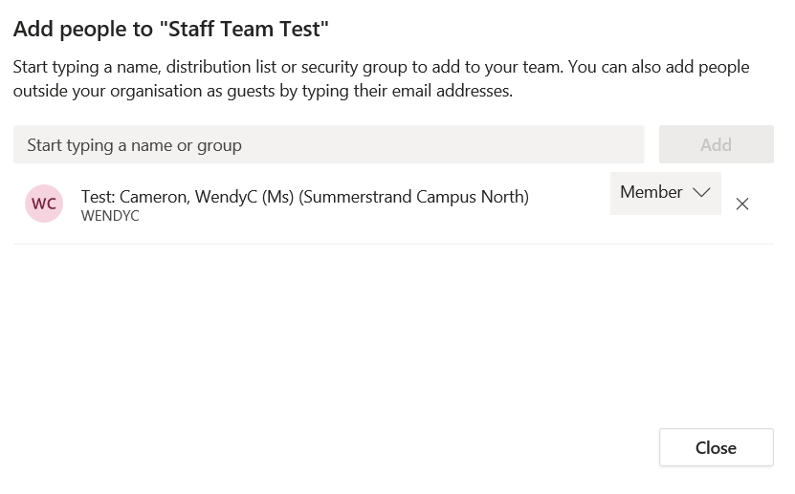
- You will now see your newly created Staff Team
